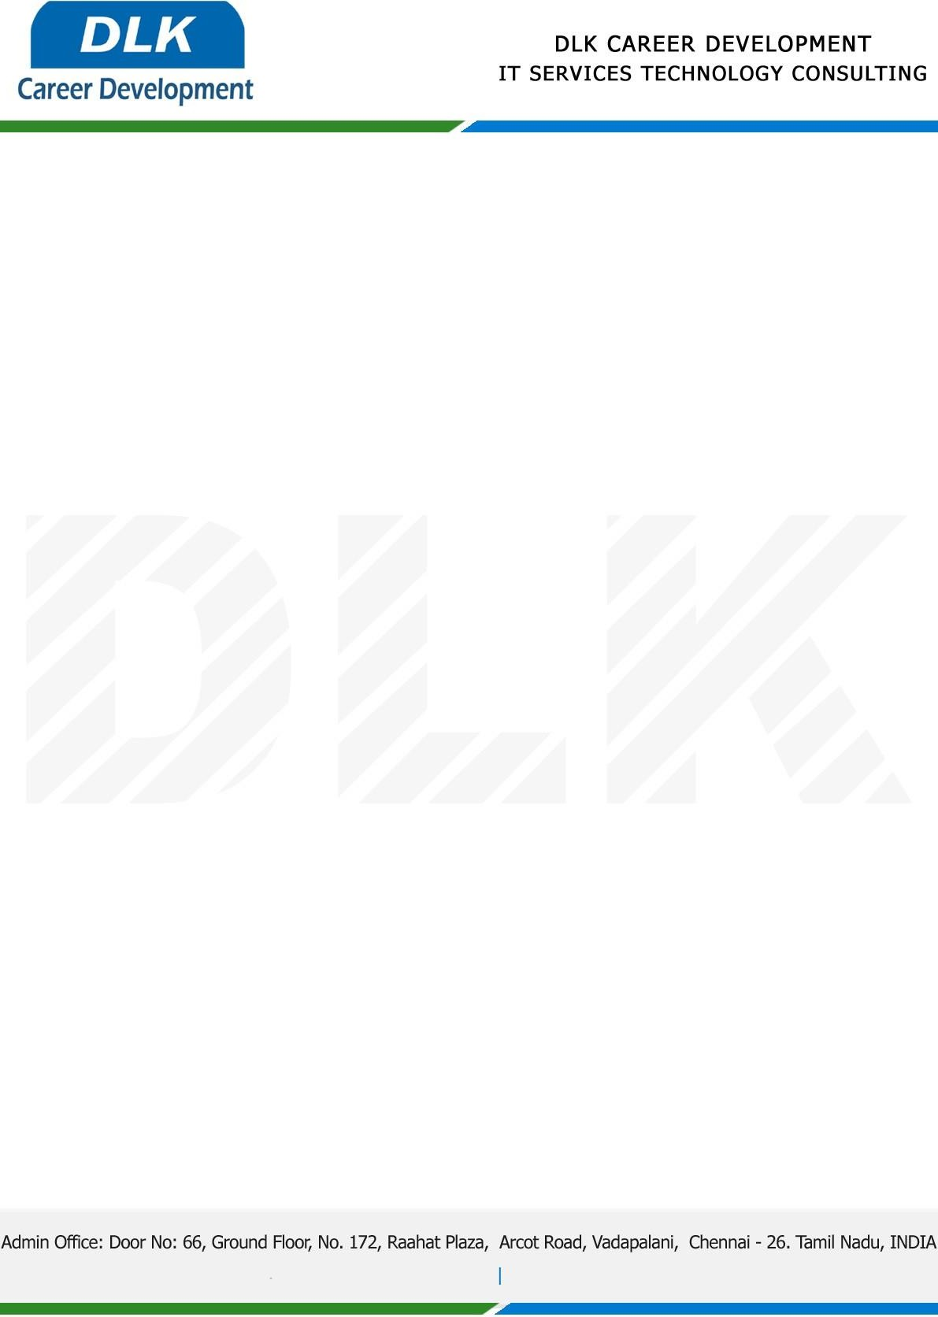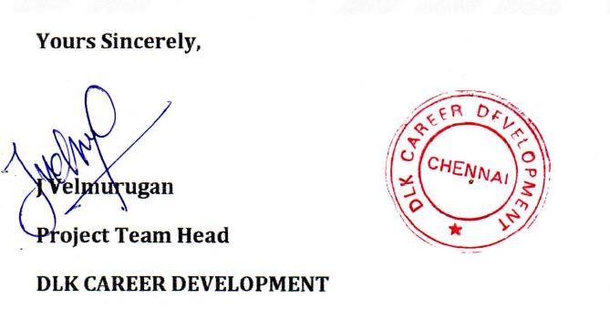

Date: 18 / January/ 2023

**To**

Department of BSC ([Computer Science),](https://www.cseindia.org/) Head of Department,

B.S. Abdur Rahman Crescent Institute of Science and Technology, Chennai - [600048](https://www.bing.com/maps?&mepi=109~~TopOfPage~Address_Link&ty=18&q=B.S.Abdur%20Rahman%20Crescent%20Institute%20of%20Science%20%26%20Technology&ss=ypid.YN4070x5949313405688057585&ppois=12.87574577331543_80.08338165283203_B.S.Abdur%20Rahman%20Crescent%20Institute%20of%20Science%20%26%20Technology_YN4070x5949313405688057585~&cp=12.875746~80.083382&v=2&sV=1) .

# Sub: Letter of Project Acceptance

This is to certify that **MR SYED LUKMAN S N (REG NO: 201371601075)** final year student of has accepted the Project Work duration from **20th January 2023 to 10th May 2023** under the domain **“Java”.** During the Project, all information and data collected from you should be kept confidential.

Topic: Reliable Transmission of Clinical Data Using Proxy Re-Encryption.

We appreciate your interest in **DLK CAREER DEVELOPMENT**